Day10&11 - Task04 - Bash Scripting Basics

What is Bash?
- Bash stands for Bourne Again SHell.
- A shell is a program that:
  - Accepts commands from the user.
  - Executes those commands.
  - Returns the output.
- Example: pwd - Bash receives the command, asks the OS for the current directory, and displays it.
What is Bash Scripting?
- Instead of running commands one by one, we can save them in a file and run the bash file whenever we want. That file can be known as Bash Script.
- Every bash file starts with ‘#!/bin/bash …’ and will be saved with the extension ‘.sh’
- Open the Terminal or command prompt on your local machine and run the following command to know which shell scripting is run as default shell on your machine.
  - echo $SHELL
- To know the bash version, use
  - bash –version
- Below are some sample scenarios where bash files are used to run a set of commands.

Note: There’s a difference while executing the bash script using ‘bash <script_name>.sh’ and ‘./<script_name>.sh’. When you use ‘bash <script_name>.sh’, you are executing the bash binary, whereas ‘./<script_name>.sh’ asks the kernel to execute the script file directly.

How ‘bash <script_name>.sh’ Works
- The Executed Program: You are manually starting the /bin/bash binary.
- The Kernel's Role: The kernel checks if /bin/bash has execute permissions (which it does) and launches it.
- The Script's Role: The bash program opens your script as a plain text file, reads the code line by line, and processes it.
- Required Permission: Because your script is just being read as data by bash, it only needs read (r) permission.

How ./script.sh Works
- The Executed Program: You are telling the system to run script.sh as a standalone executable program.
- The Kernel's Role: The kernel directly handles this request via the execve() system call. Before doing anything else, the kernel enforces security rules and checks the file's permission bits.
- The Error: Because the operating system sees the file lacks the executable flag, it immediately stops and rejects the request with a Permission denied error.
- Required Permission: The file must have execute (x) permission. If it has that permission, the kernel will read the #! (shebang) line at the top to figure out what interpreter (like bash or python) it needs to safely launch to handle the rest of the file.

- Hello World!
  - nano hello.sh - Command used to edit the new/existing file ‘hello.sh’
  - The contents of the file are as follows
    - #!/bin/bash

echo "Hello Pavan!"
echo "Welcome to Bash Scripting."
  - chmod +x hello.sh - Once hello.sh is created with the given contents, give the file permissions to execute.
  - ./hello.sh - Now run the bash file
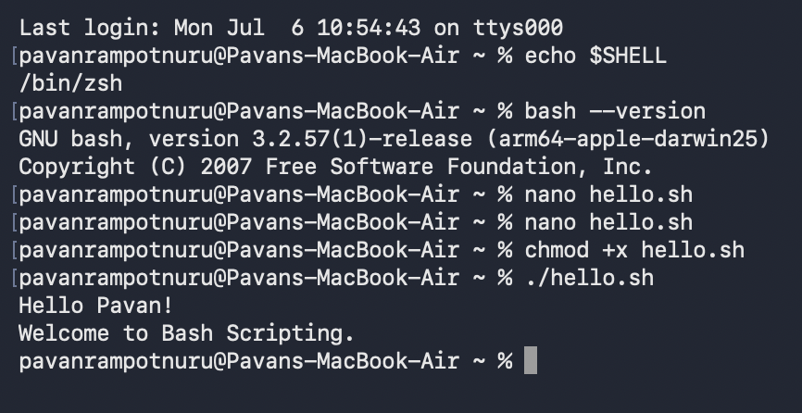
- Variables
  - nano variables.sh - Create a new file and paste the below contents.
    - #!/bin/bash

name="Pavan"
course="DevOps"

echo "My name is $name"
echo "I am learning $course"

  - bash variables.sh - run the command
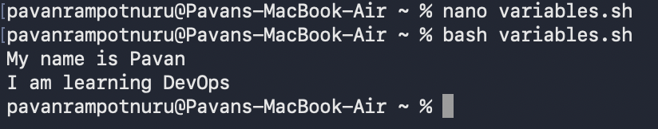

- Take User Input
  - nano input.sh - Create a new file and paste the below contents.
  - #!/bin/bash

echo "Enter your name:"
read name

echo "Welcome $name"

  - bash input.sh - run the command
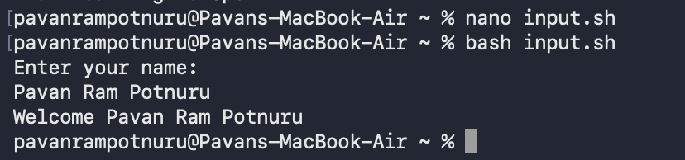

- Adding two numbers
  - nano addition.sh - Create a new file and paste the below contents
  - #!/bin/bash

echo "Enter first number:"
read num1

echo "Enter second number:"
read num2

sum=$((num1 + num2))

echo "Sum = $sum"
  - ./addition.sh - Command to run the bash script ‘addition.sh’
  - You’ll be getting an error saying, ‘permission denied: ./addition.sh’. This is because the kernel is trying to execute the script which does not have execute permissions. In the previous scenario we are using ‘bash input.sh’ to run the script, we don’t get an error. Using bash command line will directly enter the bash binary file and reads the file as an executable file. Hence we don’t need the permissions nor get the error while using ‘bash’.
  - chmod +x addition.sh - This gives the addition.sh file the execute permission and has the privilege to run from the kernel.
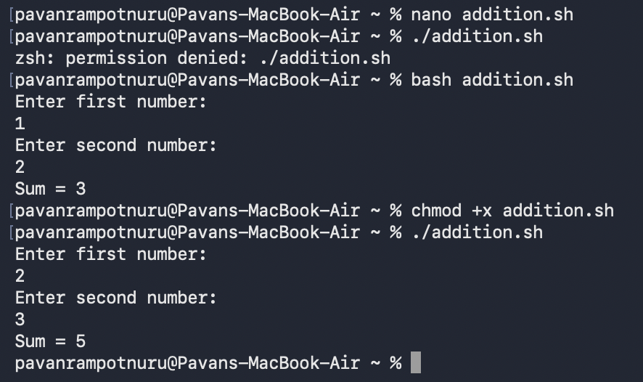

- Vote eligibility based on age
  - nano age.sh - Create a new file and paste the below contents
  - #!/bin/bash

echo “Enter your age!”
read age

if [ $age -ge 18 ]
then
echo “You are eligible to vote!!”
else
echo “You are not eligible to vote!!”
fi
  - chmod +x age.sh - Giving execute permissions to age.sh
  - bash age.sh (or) ./age.sh - Commands to run the script
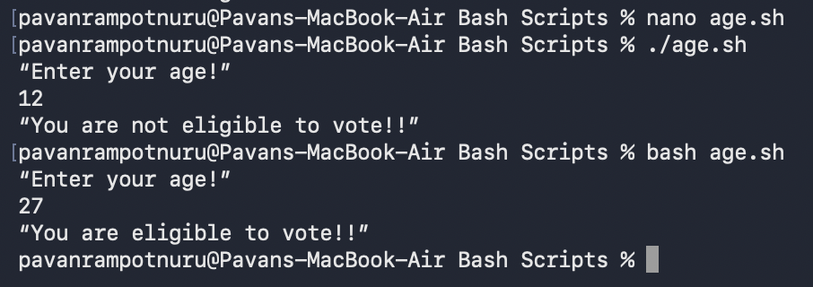

- Check whether the file exists or not!
  - nano file_search.sh - Create a new file and paste the below contents
  - #!bin/bash

echo “Enter the filename”
read file

if [ -f “$file” ]
then
echo “File exists!!!”
else
echo “File not found!!!”
fi
  - chmod +x file_search.sh - Giving execute permissions to file_search.sh
  - bash file_search.sh (or) ./file_search.sh - Commands to run the script
  - Below are some common file test operators
Operator | Meaning
-f | Regular file exists
-d | Directory exists
-e | File or directory exists
-r | Read permission
-w | Write permission
-x | Execute permission
-s | File exists and is not empty

  - We can use the above operators to check if the file/directory exist or not (or) check if the file/directory have read,write or execute permissions or not (or) check if the file is empty or not.
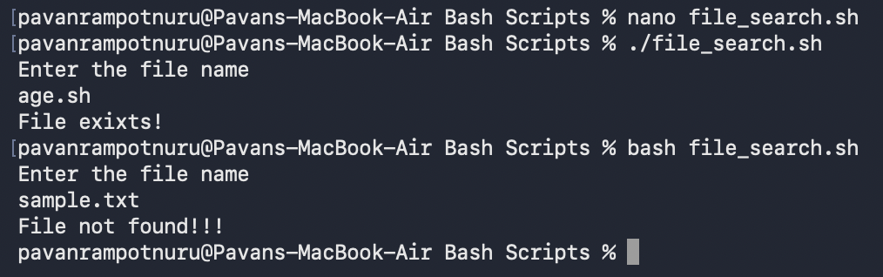

- For Loop
  - nano for.sh - Create a new file and paste the below contents
  - #!/bin/bash

for i in 1 2 3 4 5
do
echo "Number: $i"
done
  - chmod +x for.sh - Giving execute permissions to for.sh
  - bash for.sh (or) ./for.sh - Commands to run the script
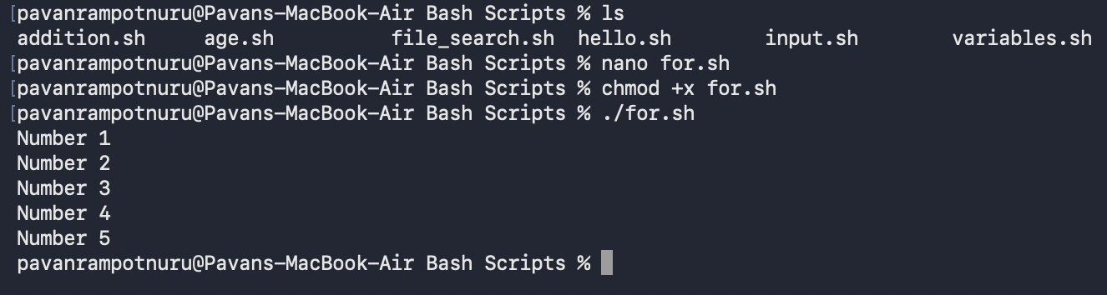

- While Loop
  - nano while.sh - Create a new file and paste the below contents
  - #!/bin/bash

count=1

while [ $count -le 5 ]
do
echo “Count: $count”
count = $((count +1))
done
  - chmod +x while.sh - Giving execute permissions to while.sh
  - bash while.sh (or) ./while.sh - Commands to run the script
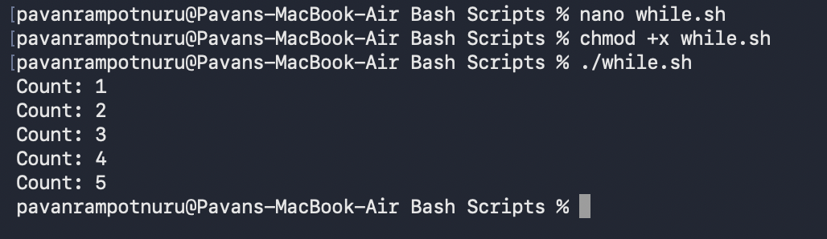

- Create and Delete Multiple Directories
  - nano mul_dirs.sh - Create a new file and paste the below contents
  - #!/bin/bash

for dir in dev test prod
do
mkdir -p $dir
echo “$dir directory created!”
done
  - chmod +x mul_dirs.sh - Giving execute permissions to mul_dirs.sh
  - bash mul_dirs.sh (or) ./mul_dirs.sh - Commands to run the script
  - nano rem_dirs.sh - Create a new file and paste the below contents
  - #!/bin/bash

for dir in dev test prod
do
rm -rf $dir
echo “$dir directory created!”
done
  - chmod +x rem_dirs.sh - Giving execute permissions to rem_dirs.sh
  - bash rem_dirs.sh (or) ./rem_dirs.sh - Commands to run the script
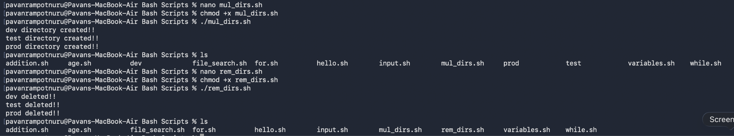
- Count files in a directory
  - nano count_dirs.sh - Create a new file and paste the below contents
  - #!/bin/bash

count=$(ls | wc -l)
echo “Total files: $count”
  - chmod +x count_dirs.sh - Giving execute permissions to count_dirs.sh
  - bash count_dirs.sh (or) ./count_dirs.sh - Commands to run the script
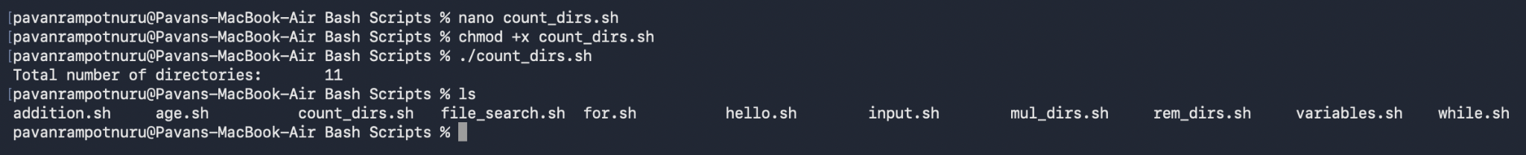

- Grades using Case Statements
  - nano grades.sh - Create a new file and paste the below contents
  - #!/bin/bash

echo "Enter your grade (A/B/C/D/F):"
read grade

case $grade in
A|a)
echo "Excellent"
;;
B|b)
echo "Good"
;;
C|c)
echo "Average"
;;
D|d)
echo "Needs Improvement"
;;
F|f)
echo "Failed"
;;
*)
echo "Invalid Grade"
;;
esac
  - chmod +x grades.sh - Giving execute permissions to grades.sh
  - bash grades.sh (or) ./grades.sh - Commands to run the script
